**[Page speed](https://pagespeed.web.dev/):**

<https://pagespeed.web.dev/>

🡪 PageSpeed Insights is a tool by Google that analyzes the performance of web pages and provides suggestions for improvements. It offers insights into how well a page performs on both mobile and desktop devices, highlighting aspects like load times and usability. By entering a URL, users can receive a detailed report on performance metrics and actionable recommendations to enhance page speed.

Analysis of my github page - https://github.com/Piyush-Goyal-Github/TR103SemanticWeb/tree/main

**Mobile View:**

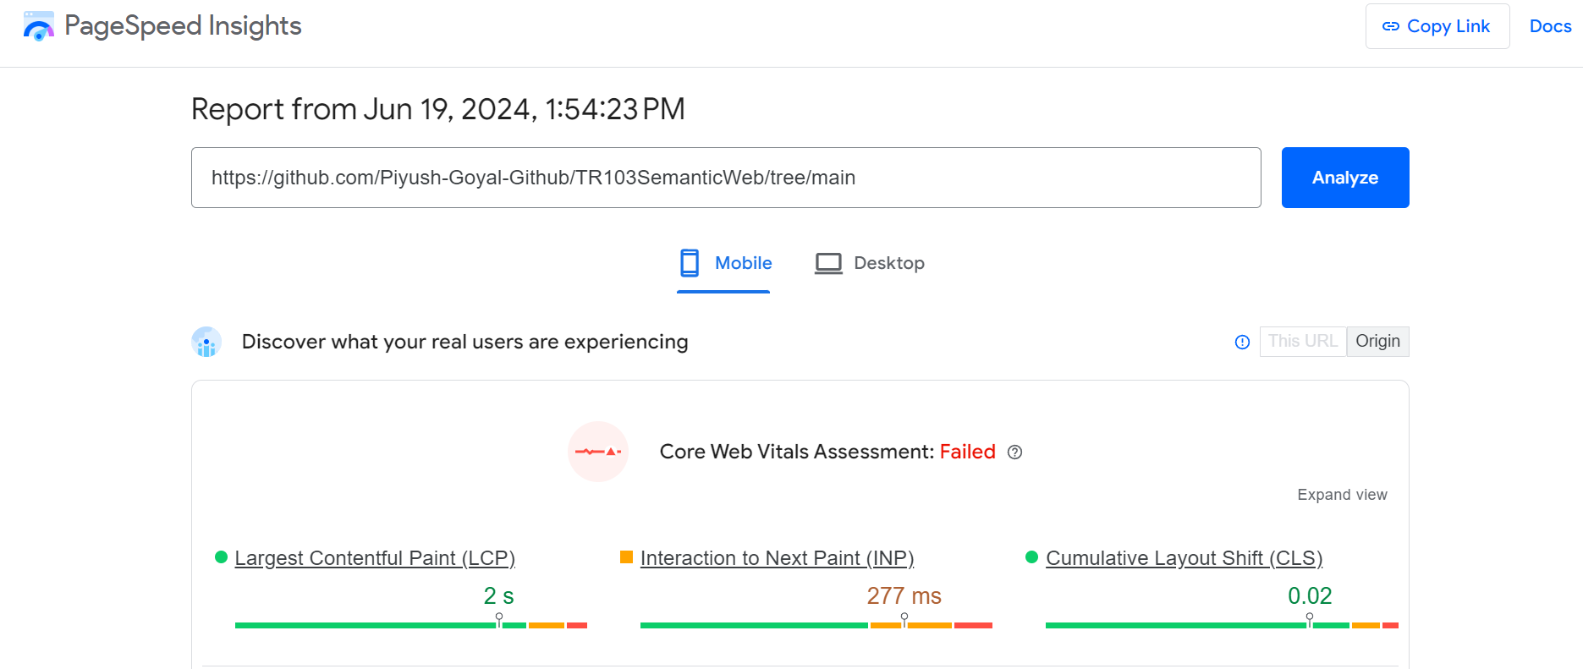

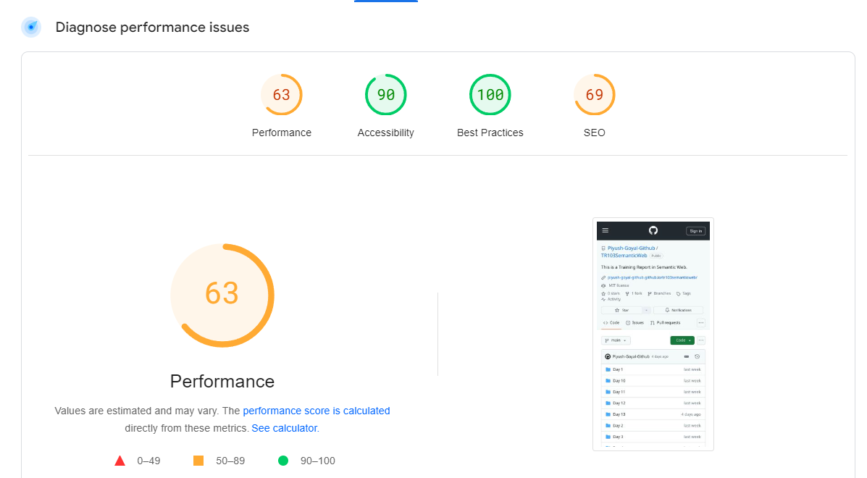

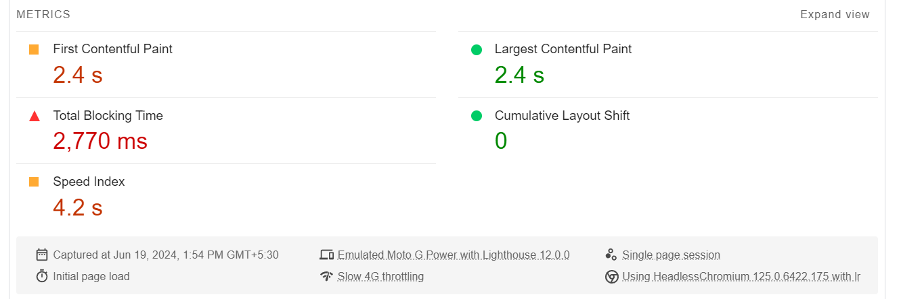

**Desktop view :**

